**All Souls Day - Plenary Indulgence Lesson**

**When:** Nov. 1-8, 2023

**Objectives:** Educate students about the importance of praying for the souls in Purgatory and how they can play an active role in Christ’s gift of salvation by their participation and cooperation in His work of salvation and sanctification through intercessory prayer. Explain to them that praying for the souls in Purgatory is putting into practice the virtue of charity. Provide students with a structured opportunity to offer prayers for loved ones who are deceased and for forgotten souls with nobody to pray for them during the week of All Saints / All Souls Day.

**Vocabulary:**

*Soul* - the spiritual immortal part in human beings that animates their body

*All Souls Day* - a holy day set aside to pray for the purification and happy repose of the souls of the dead in the Risen Lord (November 2)

*Purgatory* - a process of purification to achieve the holiness necessary to enter the joy of Heaven

*Temporal punishment* - a temporary penalty imposed on us, either on earth or in purgatory, by which we make satisfaction in time for disturbing God’s order. Through the Sacrament of Reconciliation, we are forgiven because of the Blood of the Lamb of God, but God still wants us to do penance (prayers, sacrifices) to experience purification and healing after our sins have been forgiven.

*Indulgence* - a remission (or cancellation) before God of the temporal punishment due to sins whose guilt has already been forgiven

*Plenary indulgence* - a full remission of temporal punishment

*Partial indulgence* – a partial remission of temporal punishment

**Background for teaching:**

*Why do we commemorate All Souls Day?*

<https://www.osv.com/Article/TabId/493/ArtMID/13569/ArticleID/11321/All-Saints-and-All-Souls-Days.aspx>

<https://www.catholic.org/saints/allsouls/>

*What does the Catholic Church say about temporal punishment and indulgences?*

[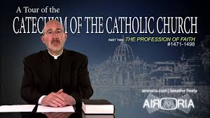](https://www.youtube.com/watch?v=BGTzUKG6O14) INTRODUCTORY VIDEO: <https://www.youtube.com/watch?v=BGTzUKG6O14>

<https://www.catholic.com/tract/primer-on-indulgences>

*How does All Souls Day connect with these Church teachings and how can I help the souls in Purgatory through my prayers?*

<http://www.ncregister.com/blog/joseph-pronechen/purgatory-souls-are-sending-their-november-sos>

<https://www.catholicculture.org/culture/liturgicalyear/activities/view.cfm?id=1178>

**Saints’ quotes on Purgatory:**

*“I come to tell you that they suffer in Purgatory, that they weep, and that they demand with urgent cries the help of your prayers and your good works.”* – St. John Vianney

*“If, during life, we have been kind to the suffering souls in purgatory, God will see that help be not denied us after death.”* – St. Paul of the Cross

*“The practice of recommending to God the souls in Purgatory, that He may mitigate the great pains which they suffer, and that He may soon bring them to His glory, is most pleasing to the Lord and most profitable to us. For these blessed souls are His eternal spouses, and most grateful are they to those who obtain their deliverance from prison, or even a mitigation of their torments. When, therefore, they arrive in Heaven, they will be sure to remember all who have prayed for them.”* – St. Alphonsus Maria de Liguori

*“Let us help and commemorate them. If Job’s sons were purified by their father’s sacrifice (Job 1:5), why would we doubt that our offerings for the dead bring them some consolation? Let us not hesitate to help those who have died and to offer our prayers for them.”* – St. John Chrysostom

**Activities:**

**(There is a separate spiritual bouquet card in this packet for non-Catholic students who wish to participate)**

*Instruction on salvation through Jesus, types of sin, the souls in Purgatory, why we pray for them and that they pray for us, and the process for obtaining a plenary or partial indulgence via theology classes

*All Saints Day Mass (November 1)

*Opportunities for students and school community members to choose to receive the Sacrament of Reconciliation during the school day on a designated day between Nov. 1 and 8 (eight days before or after Nov. 2 also suffices).

*Opportunity for prayer

*Opportunity for students to record the name of the person for whom they’ve offered the indulgence

*Recording of the indulgences that students have earned

*Prayer service on Nov. 9 with an offering of the records at the altar

**Infographic on the process of obtaining an indulgence:**

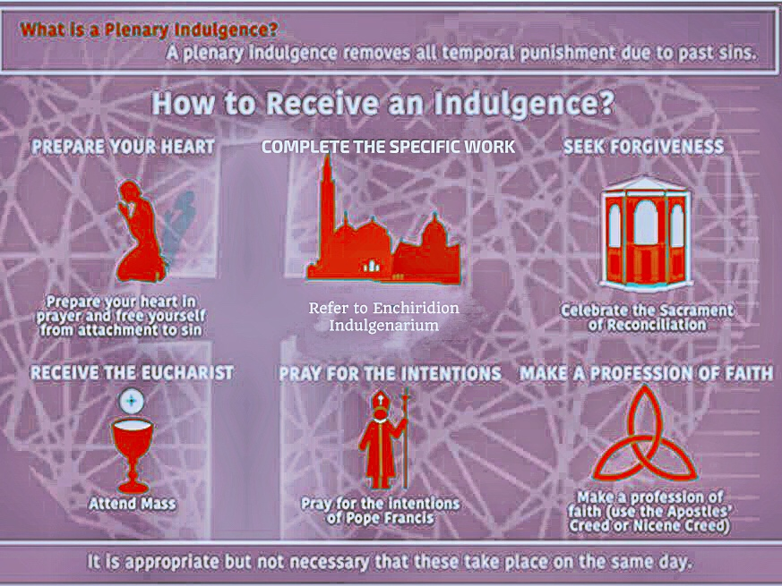



**Indulgence Offering Pledge Card – All Souls Day**

Eternal Father, I offer this indulgence for the soul of

______________________________________________.

May eternal rest grant onto him/her, O Lord, and may perpetual light shine

upon him/her.

**Checklist:**

1. __________ Prepare your heart in prayer & free yourself from attachment to sin

2. __________ Receive Holy Communion **once per indulgence offered**

between Nov. 1 and 8

3. __________ Celebrate the Sacrament of Reconciliation between Nov. 1 and 8

4. __________ Pray the Apostles’ or Nicene Creed

5. __________ Pray for the intentions of Pope Francis (Our Father and Hail Mary)

6. __________ Complete the specific work:

*A. Visiting a church on All Souls Day & praying Our Father & Creed*

*B. Visiting a church on the Sunday before or after All Souls Day & praying*

*Our Father & Creed*

*C. Visiting a church on All Saints Day & praying Our Father & Creed*

*D. Visiting any cemetery and praying for the deceased*

*I believe in God, the Father Almighty, Creator of Heaven and earth; and in Jesus Christ, His only Son Our Lord, Who was conceived by the Holy Spirit, born of the Virgin Mary, suffered under Pontius Pilate, was crucified, died, and was buried. He descended into Hell; the third day He rose again from the dead; He ascended into Heaven, and sitteth at the right hand of God, the Father almighty; from thence He shall come to judge the living and the dead. I believe in the Holy Spirit, the holy Catholic Church, the communion of saints, the forgiveness of sins, the resurrection of the body and life everlasting. Amen.*



**Spiritual Bouquet Pledge Card – All Souls Day**

Eternal Father, I offer this spiritual bouquet for the soul of

______________________________________________.

May eternal rest grant onto him/her, O Lord, and may perpetual light shine

upon him/her.

**Checklist:**

1. __________ Prepare your heart in prayer & free yourself from attachment to sin

2. __________ Attend Church once per spiritual bouquet offered

between Nov. 1 and 8

3. __________ Pray for a conversion of the world from sin

4. __________ Complete the specific work:

*A. Visiting a church on All Souls Day & praying*

*B. Visiting a church on the Sunday before or after All Souls Day & praying*

*C. Visiting a church on All Saints Day & praying*

*D. Visiting a cemetery and praying for the deceased*